Supplementary Materials
Disaggregating “pure” and “hybrid” schedules

Here we consider results disaggregated into more granular types of training schedules (pure vs. hybrid; Supplementary Figure 1). In addition to AC integration, we assessed the indirect AC association by using the activation (e.g., retrieval) strength of item C given item A. To obtain an activation strength, we applied a sigmoid function to the outputs of the neural networks. This sigmoid function produces a probability value ranging from 0 to 1. Memory capacity also affects the retrieval of item C given item A. This retrieval strategy is a distinct process from the pattern completion strategy that benefits from AC integration. We operationalize the retrieval strength as the magnitude of the sigmoid activation of item C when the model is given item A as input. Higher memory capacity allows for training to reach a higher activation of C given A than lower memory (Supplementary Figure 2A). The hybrid schedules appear to show stronger C activation than the pure schedules. Indeed, this benefit of the hybrid schedules for C activation is particularly prominent when memory is low (Supplementary Figure 2B). As memory capacity increases, the C activation increases overall and differences between the hybrid and pure schedules are diminished. These results show that the hybrid and pure schedules, despite both containing blocked and interleaved schedules, are not equivalent. Rather the hybrid schedule confers a benefit towards the retrieval strategy over the pure schedule.

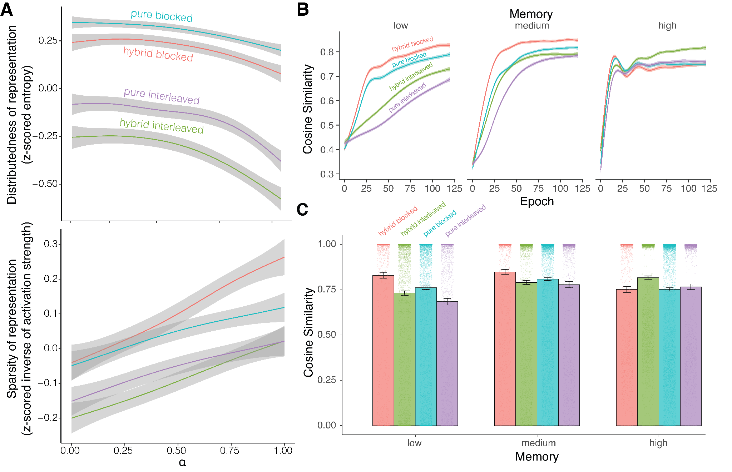
Supplementary Figure 1. Effect of hybrid versus pure schedules on AC integration. (A) These are more granular results of Figure 2 from the main text, separated by the “pure” or “hybrid” types of the schedule. For the blocked schedule, the pure schedule resulted in higher distributedness and lower sparsity whereas the hybrid schedule resulted in lower distributedness and higher sparsity when controlling sparsity with the parameter α. For the interleaved schedule, the pure schedule resulted in more distributedness and more sparsity whereas the hybrid schedule resulted in less distributedness and less sparsity. (B) The learning curves were also split by the pure or hybrid schedule type. (C) The magnitude of integration of A and C differs by pure or hybrid schedules, but schedule format (pure vs. hybrid) did not fundamentally change the pattern of results with respect to which schedule is optimal under varying capacity conditions (e.g., blocked > interleaved in low capacity conditions, regardless of format).
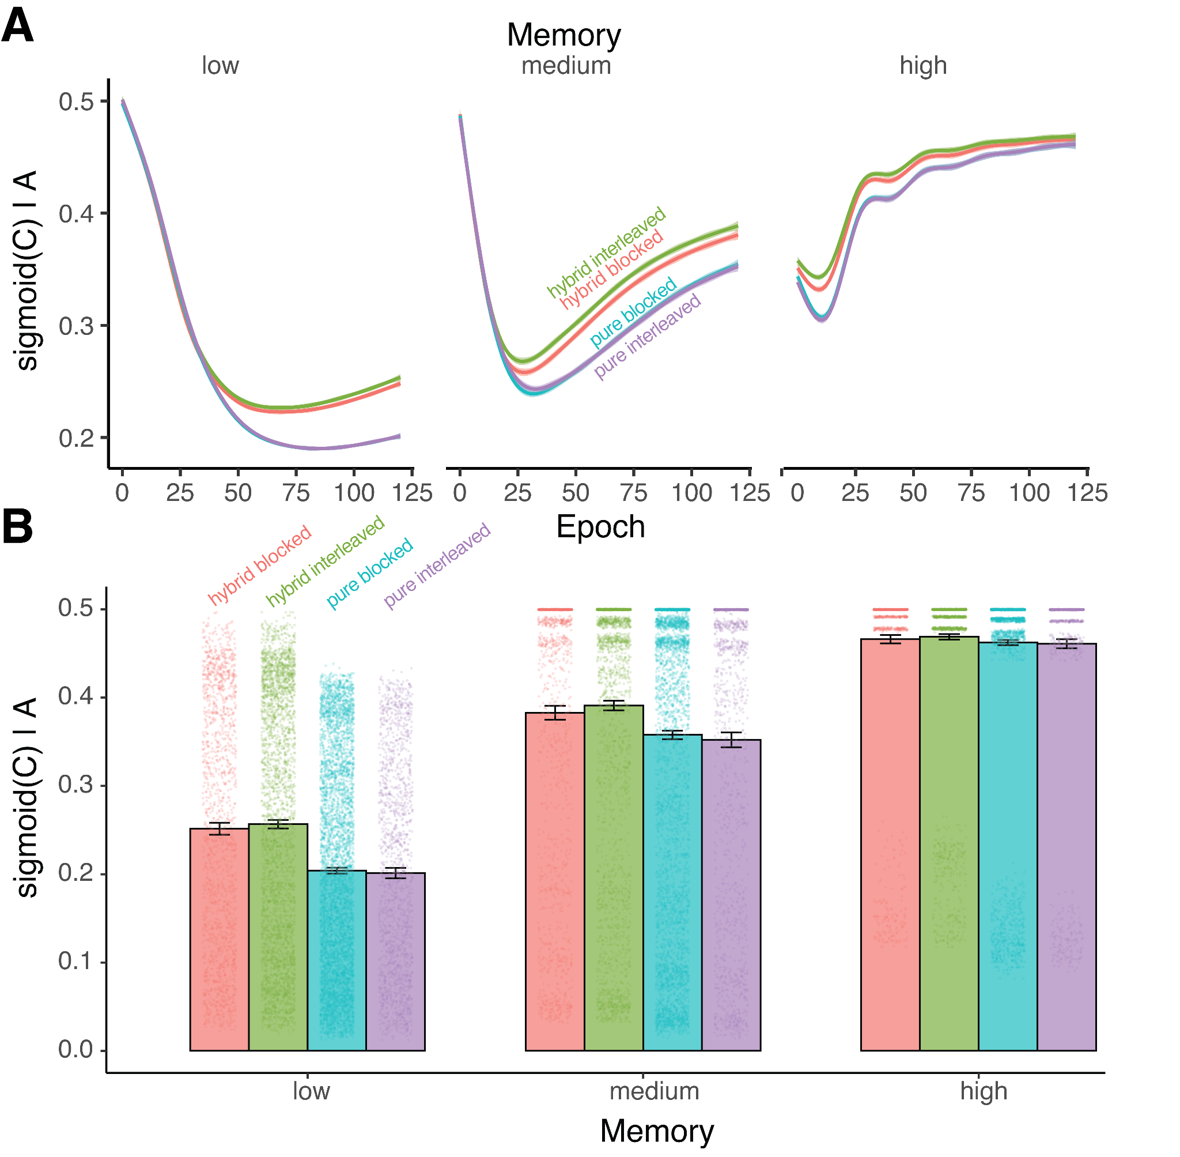
Supplementary Figure 2. Learning indirect AC association by retrieving C. (A) The activation of item C given item A for different memory capacities as the models are exposed to items from different schedules. The activation strength was greater for hybrid schedules than pure schedules across memory capacities. (B) The strength of retrieval for item C when presented with item A depends was measured as the sigmoid activation of item C given item A. The retrieval strengths increase with memory capacity. Retrieval benefits from hybrid versus pure schedules. Outputs appear stratified due to our parameter sweep and the input-output non-linearity of the sigmoid function being more extreme at the midpoint. Error bars depict 95% confidence intervals.

Catastrophic interference as a possible modeling confound

Trained models often fail to learn both direct pairs because BC learning may partially overwrite AB. An important confound to consider is whether greater AC similarity is an artifact of a degenerate state of the model that is suffering from catastrophic interference. We consider models to be learning AB when AB cosine similarity increases and BC when BC cosine similarity increases. We quantify evidence of BC overwriting AB (catastrophic interference) as when BC similarity is greater than AB similarity and AB minus BC similarity is negative. When the BC association is being learned the AC association is unlearned. The Spearman’s correlation between AB-BC similarity and AC similarity is modest: rho=-0.08, p<0.001. In the lowest memory models where catastrophic interference would presumably be most severe, there is no correlation (rho=-0.005, p=0.56).
Nevertheless, there is evidence in the low memory models that catastrophic interference could explain our models (Supplementary Figure 3). Low memory models are especially susceptible to such overwriting. However, the models with medium and high memory still exhibit the pattern of results we report in the main results.
To further investigate the importance of direct pair learning, we trained another set of models with larger capacity to evaluate the importance of direct pair learning for our main results (Supplementary Figure 4). All models now have greater capacity relative to the input dimension, where the encoding layer is expanded to low having 128 units, medium having 256 units, and high having 384 units. We obtain above-chance performance (50% in binary choice tests of target versus foil) in direct pair learning of AB and BC. The Spearman’s correlation between AB minus BC similarity and AC similarity is modest: rho=-0.05, p<0.001. The lowest capacity model exhibited a slightly higher correlation of rho=0.07, p<0.001.
When memory capacity is low, we hypothesized that presenting related episodes in a blocked sequence would allow AB associations to stabilize before BC is introduced. Consistent with this hypothesis, neural network architecture can produce greater AB accuracy during and after blocked training relative to interleaved training (Supplementary Figure 4). At the same time, introducing BC pairs initially produces more competition between AB and BC in blocked than interleaved sequences. With that said, the competition is temporary and the networks continue to steadily improve performance across training such that both AB and BC performance “stabilize” while AC inference performance improves. This pattern of performance is consistent with the account that blocking in low-capacity networks is yielding a lossy, compressed ABC representation that supports AC inference which may come at the cost of some degradation in pair-specific (AB, BC) fidelity.
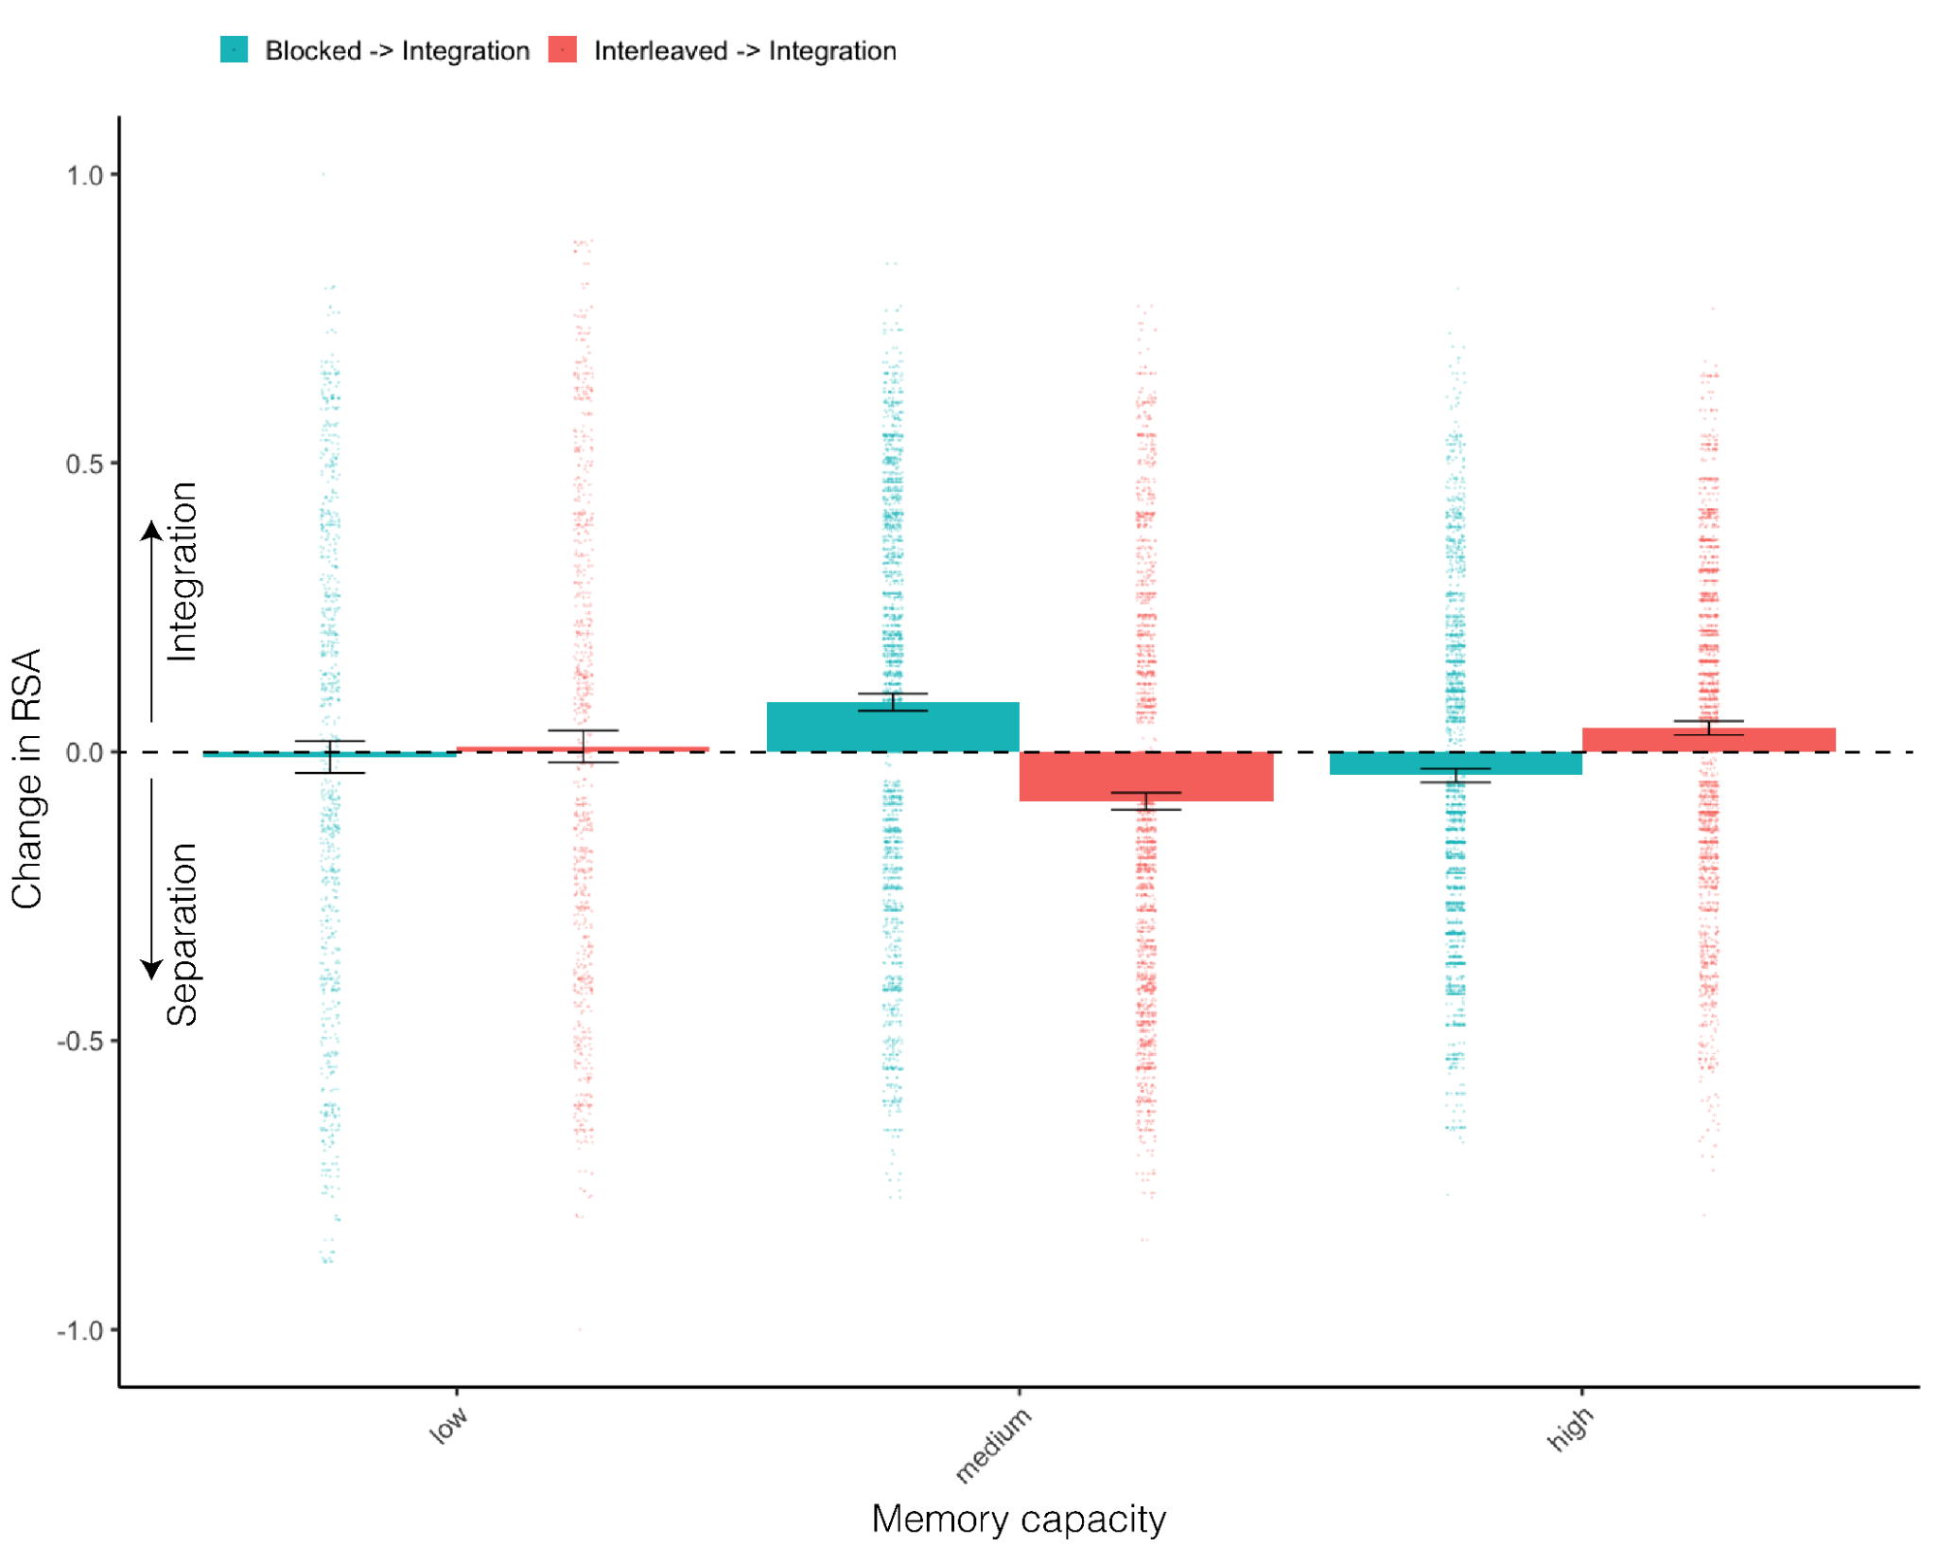

Supplementary Figure 3. Representational similarity analysis with top and bottom 5th percentiles of ceiling and floor associations excluded. While the original low memory model results appear driven by ceiling and floor associations, the models with higher memory remain consistent with the original results. These findings reinforce the importance of memory capacity for the integration of representations.

This modest relationship between AC similarity and direct pair performance suggests that the degenerate state of the model is not a confound which can fully explain these modeling results.

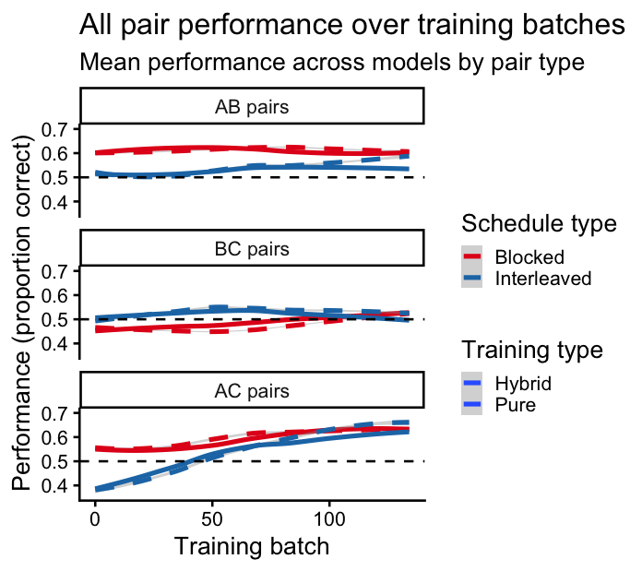

Supplementary Figure 4. Performance over training for direct and indirect pairs. A new set of models with larger memory capacity (low having 128 units, medium having 256 units, and high having 384 units) exhibit direct and indirect pair learning. Correct performance is determined by learned representations with greater cosine similarity of direct pairs (e.g. A1-B1) than the cosine similarity of foil pairs (e.g. A1-B3). Foils were selected such that one element of the pair is from a different triad but still within the same schedule type (e.g. not A1-B6). The dashed horizontal line indicates chance performance for the two-forced choice task of whether target similarity is greater than foil similarity.

Relatedly, one interpretation of the integrative encoding hypothesis is that integration may benefit from maintaining a high-fidelity A-B association. In our model, this maintenance of the A-B association should be reflected in a greater likelihood of retrieving the associated target than retrieving an unassociated foil within that experimental condition (blocked vs. interleaved). Across the low, medium, and high capacity models, the final models reported in the main text maintain this hypothesized pattern of results, suggesting maintenance of the target A-B association (Supplementary Figure 5). Specifically, target retrieval (e.g. A1|B1 and B1|A1 within a triad) was greater than foil retrieval (e.g. A1|B3 and B3|A1 within condition). While such differences suggest maintenance of useful direct pair representations for various potential integrative processes, the magnitude of this difference was smallest in the low-capacity models for blocking, consistent with greater competition and interference. Moreover, the probabilities of target retrieval were generally lower after blocking. This lower probability points to a stronger competition and interference effect between the blocked and interleaved experimental conditions the models were trained on (e.g. A1|B6 and B6|A1 between conditions).
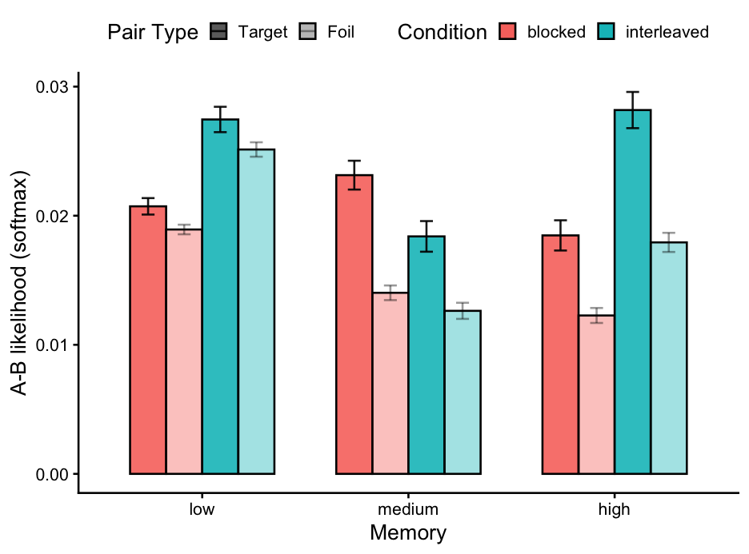
Supplementary Figure 5. Discriminative learning of associated pairs under competition across conditions. Target retrieval (e.g. A1|B1 and B1|A1 within ABC triad 1) was greater than foil retrieval (A1|B3 and B3|A1 within the condition). This suggests that the models–across memory and task conditions–learned the trained associations. However, the relatively low average retrieval probabilities overall suggest competition and interference between schedules (A1|B6 across blocked and interleaved schedules).

Memory capacity and representational dimensionality

Memory capacity. We operationalized memory capacity as dimensional expansion or compression across two encoding/decoding layers, with a fixed-size embedding layer to support comparable representational similarity outcomes and analyses. Under-complete (integrated) codes encourage compact, interference-resistent memory, whereas over-complete (separated) codes support flexible, robust representations (Kumaran & McClelland, 2012; Treves & Rolls, 1994). The width of the embedding layers in the “low” and “high” memory conditions were chosen based on conceptual abstractions of our framework–in the “low” memory capacity model, we picked a size that was smaller than the input layer, forcing a many-to-one mapping of incoming information. In doing so, we aimed to create a condition of high interference pressure, similar to what we believe individuals with poor memory abilities chronically face. We chose to reduce the 18-dimensional stimuli to 6 dimensions then to 3 dimensions, reflecting a 3:1 and then 2:1 compression ratio during encoding (and vice versa for the expansion ratio during decoding). These ratios are within the biological 5:1 range observed for the input-output

